**Andrew Denewellis**

**Product Usage Map**

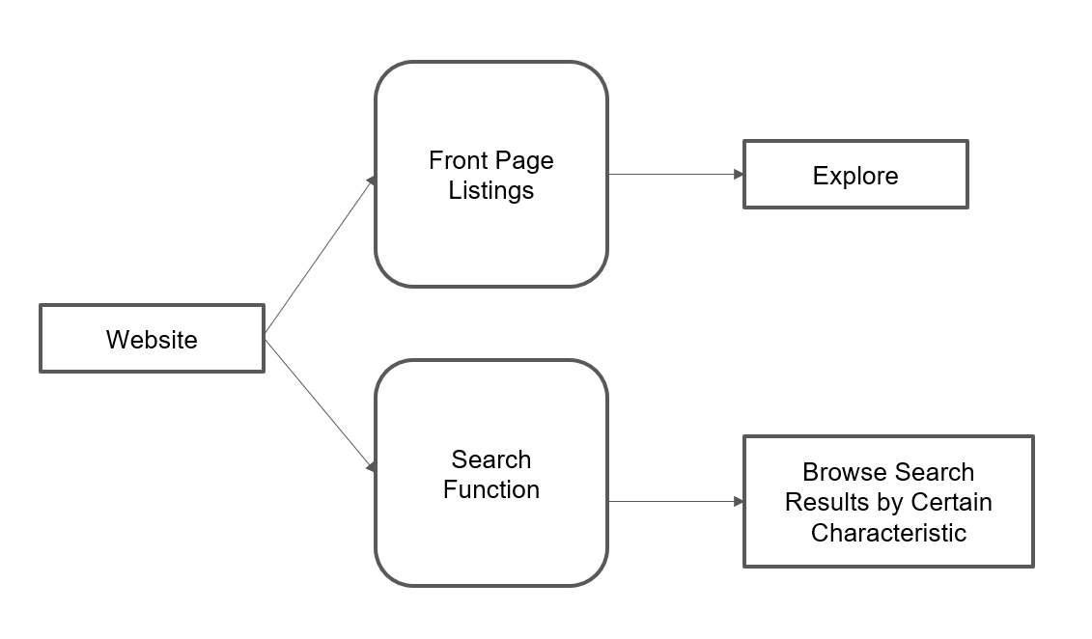

**Scenarios**

* Sam struggles to balance her high school workload with the amount of time she wants to relax watching television. After studying for an upcoming exam in the library, she relaxes on the couch at home but struggles to find anything she wants to watch. Sam decides to try out CheckFlix so that she can narrow down her options based on her favorite genres.
* James, after getting home from work, sits down with his six year old daughter. They love to watch television together, but James has been struggling to find any age-appropriate shows that are also new. James visits CheckFlix so he can find programs for young children that were released within the last three months.
* Tom and Mary are looking for a new series for them to binge watch together on Netflix. However, they can’t agree whether they should watch a comedy or a drama series. Using CheckFlix’s search features, they are able to easily find series that fall in both genres.
* Bob, a college student and movie enthusiast, is looking for more series and movies that star his favorite actor, Christopher Lloyd. He goes on to CheckFlix and searches for shows and movies on Netflix that feature the actor so he can follow his career.

**User Stories**

* As a teenager in high school, I want a quick search tool so that I can quickly find new series that might interest me.
* As a father, I want to be able to find age-appropriate shows for my preschool age daughter.
* As a couple, we want to be able to find shows that we both want to binge together.
* As a college student, I want to be able to follow my favorite actor through every series or movie they have starred in that is on Netflix.

**Feature List**

* Front splash page with trending shows
* Search functionality by:
  + Genre
  + Age Rating
  + Featured Actors
  + Title
  + Date originally released
  + Date added to Netflix
  + Length/Running Time
* Ability to store/favorite search results.